Step1: Open video
Like
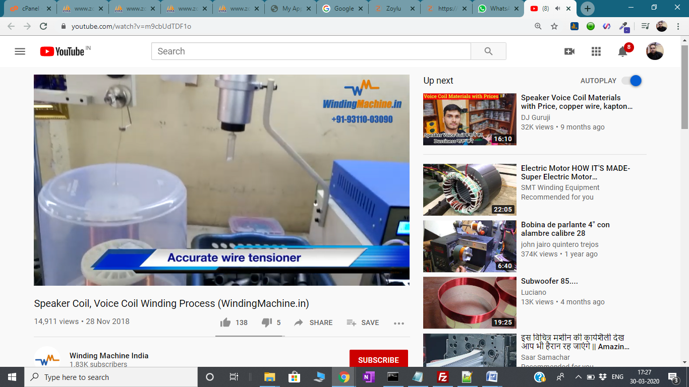
Step 2:
Click the “SHARE LINK” as image Red mark


Step 3:
Click “Embed link” as Image red mark
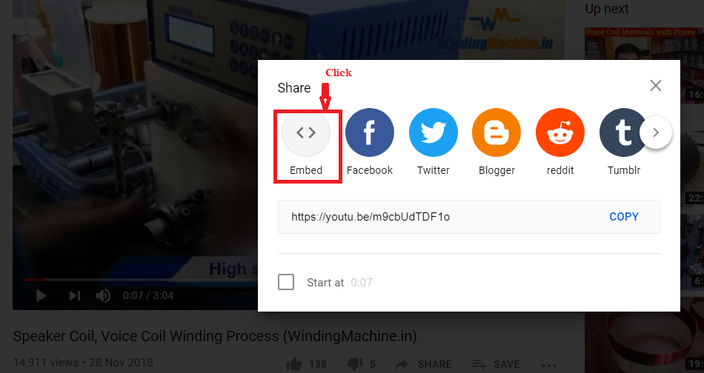

Step 4:
Copy “src value” like https://www.youtube.com/embed/m9cbUdTDF1o as image “cover by Blue color ”
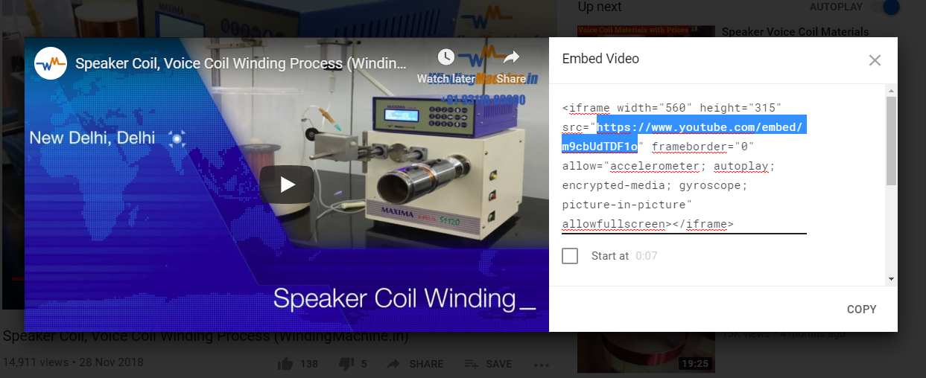

Step 5:
- Then open Admin panel
- edit product and pest
- Then pest (copied code like=’ https://www.youtube.com/embed/m9cbUdTDF1o’) in Video Url field
- Save

Example as I Used product sku = CT250-G
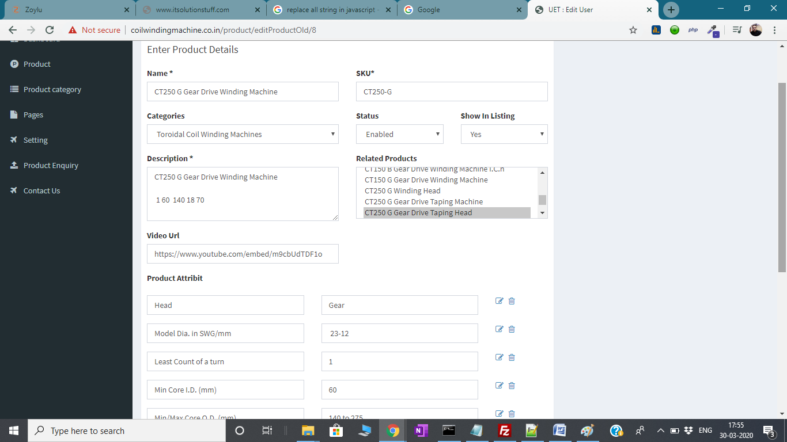

Front end
